 Updating W-4 Information

Begin by navigating to the W-4 Tax Information page by clicking on the “W-4 Tax Information” tile

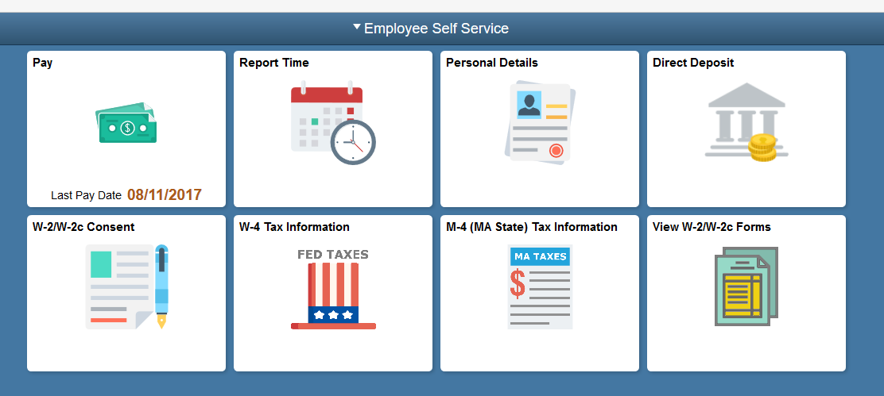

Use the W-4 Tax Information page to change federal tax data only. The text at the top of this page provides useful information about federal taxes and the use of this form.
Click here to access W4 form instructions and worksheet link.
Form W-4 Instruction PDF document opens in a separate window.
You may print the form and use the Personal Allowances Worksheet section to determine your number of allowed exemptions.
Click the Close button.
You will update the total number of Allowances you wish to claim.
Enter the desired information into the Enter total number of Allowances you are claiming field.

Enter a valid value e.g. "0".
If you want to have an additional amount withheld from each paycheck, you would enter the amount in this field.
Your Marital Status has recently changed. You will update your marital status.

Click the Married option.
Click the Scrollbar.

You wish to claim exemption from withholding for the current year.

Read both conditional statements to confirm that you meet both conditions.
Click the Check 'Exempt' here if you meet both conditions option.
Click the Scrollbar.

Click the Submit button.
Click the OK button.
Your updates display on the page.

Congratulations! You have successfully reviewed and changed W-4 Federal Tax data.
End of Procedure.

